Kol Simcha Torah Gazette
For Vayakhel-pekudei 5786
Vol 10 Issue 23 (Whole #489) 25 Adar 5786/ March 14, 2026
Printed L’illuy nishmas Nechama bas R’ Noach, a”h
For a free subscription, please forward your request to keren18@juno.com
Past emails can be found on the website ShabbosStories.com under Brooklyn Torah Gazette

Is It Proper to Rejoice
Over Khamenei’s Death?
By Jeff Jacoby

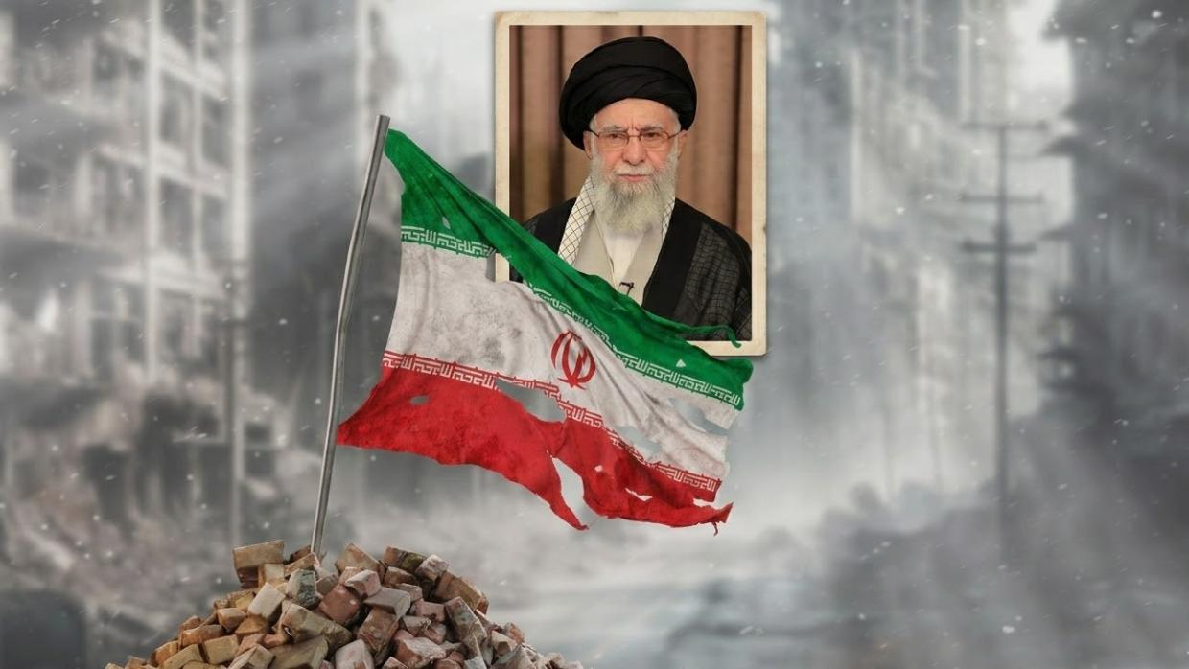

Iranians danced in the streets. Western journalists mourned his "easy smile." Who actually knew Khamenei better?
"With his spectacles, Palestinian kaffiyeh, long robes, and silver beard, Ayatollah Khamenei cast himself as a religious scholar as well as a writer and translator of works on Islam. He affected an avuncular and magnanimous aloofness, running the country from a perch above the jousting of daily politics."
That lyrical passage is from The New York Times's obituary of Iran's supreme leader, who was killed Saturday when US and Israeli forces reduced his Tehran compound to rubble. The Washington Post likewise made a point of softening and humanizing the dead dictator, recalling his "bushy white beard and easy smile" and noting that he was "fond of Persian poetry and classic Western novels." Khamenei's literary life was also played up by The Guardian, which noted that the ayatollah had been an "avid" reader who adored "Les Misérables," which he "described as 'miraculous' and a 'book of wisdom.'"
To judge from such passages, as Maya Sulkin observed in The Free Press, one might imagine that Khameini's truest essence was that of a bookish scholar, rather than a theocratic tyrant who spent nearly four decades imprisoning, torturing, and executing innocent victims.
But the Iranians who had actually lived under Khamenei's rule were not reading obituaries. They were rejoicing.
In Tehran, residents leaned from windows and gathered on rooftops, shouting with joy and excitement. Video from across Iran showed people dancing in the streets at news that the ayatollah was dead. In Los Angeles, London, and Toronto, members of the Iranian diaspora poured out to celebrate. Representative Yassamin Ansari, an Arizona Democrat and the first Iranian American elected to Congress, spoke for millions when she said simply: "Khamenei was the epitome of evil. No one should mourn him."
Why were Iranians rejoicing? Because for nearly four decades, Khamenei made their lives a waking nightmare. He imprisoned women for showing their hair, hanged gay men in public squares, executed dissidents by the thousands, and ran Evin Prison — where rape and psychological torture were standard practice — as an instrument of state terror.
When 22-year-old Mahsa Amini died in custody in 2022 after being arrested for wearing her hijab improperly, and millions took to the streets in protest, he responded by killing more than 500 of them and imprisoning 22,000 more. When a fresh uprising erupted this past January, he massacred tens of thousands.
Why were Iranians rejoicing? Because for nearly four decades, Khamenei made their lives a waking nightmare.
That was what he did at home. Beyond Iran's borders, Khamenei sponsored the terror network — Hamas, Hezbollah, the Houthis — that has kept the Middle East drenched in blood for decades. He facilitated President Bashar al-Assad's slaughter of some 500,000 Syrians, most of them Sunni Muslims. He directed the killing of hundreds of Americans, from the 1996 Khobar Towers bombing in Saudi Arabia to the roadside bombs that tore through US troops in Iraq.
For 37 years he bankrolled and armed the jihadist proxies whose explicit mission was the annihilation of Israel — a campaign that sent many thousands of innocent men, women, and children to early graves. And all the while he proclaimed "Death to America, Death to Israel" — not as hyperbole, but as official state doctrine.
Yet there are those for whom none of that is sufficient reason to welcome Khamenei's demise. Hasan Piker, a left-wing streamer with millions of online followers, scolded Iranians for cheering the US-Israeli strikes that killed the ayatollah, asking how "civilian deaths can ever be justified as progress."
Rajdeep Sardesai, one of India's best-known journalists, pronounced such celebrations "fraught — morally, diplomatically and strategically" and expressed dismay that anyone could applaud a political leader's death. And Pastor Pete Pawelek, an evangelical minister, grounded his objection in religion. As a Christian, he wrote, "I do not celebrate the death of a man, even one associated with grave evil." It is never right, they and others insist, to rejoice at anyone's death.
They're wrong. Such objectors always are.
When Saddam Hussein was hanged in 2006, European governments deplored his death as "barbaric." When Seal Team Six killed Osama bin Laden in 2011, some American commentators were appalled by the spontaneous jubilation that ensued. Each time a monstrous tyrant is brought to justice, the same chorus arises, citing whatever principle is nearest to hand — Christian humility, diplomatic decorum, progressive solidarity.
"This is something we've been asking for, begging for, crying for, for 47 years, and finally it's done."
But the elimination of evil and homicidal despots makes the world a better place. When a man who spent decades inflicting horror on innocents meets his end, good people rejoice.
Western obituary writers may have been taken with the late ayatollah's "avuncular and magnanimous aloofness," but the liberated Iranians dancing in the streets knew him rather better than that. One expatriate spoke for millions: "This is something we've been asking for, begging for, crying for, for 47 years, and finally it's done." That outpouring of joy is the most honest obituary Khamenei will ever receive.

Reprinted from the current website of aish.com This op-ed originally appeared in The Boston Globe

The Origins of the Terrible
Misconception of the Menorah
From the Teachings of the Lubavitcher Rebbe
Rabbi Menachem Mendel Schneerson, Zt”l

"And he made the candlestick of pure gold," we read in this week's Torah portion, Vayakhel. "And six branches were coming out of its sides: three branches of the candlestick out of its one side, and three branches of the candlestick out of the other side."
Surprisingly, a widespread misconception exists concerning the menora that stood in the Holy Temple.
This misconception, whose origin lies in non-Jewish sources, has unfortunately filtered down into Jewish circles, resulting in a faulty understanding of the genuine appearance of the menora.
In truth, the six side branches of the seven-branched candelabrum rose upward diagonally in a straight line from the center; they were not, as is commonly pictured, rounded in a bow-shape.
What makes this error even more regrettable is that it is derived from the famous Arch of Titus, may his name be blotted out forever.
The Roman emperor, seeking to memorialize his destruction of the Second Holy Temple and his pillage of the Temple's vessels, commissioned a work to secure his place in history. Its depiction of the menora, however, is not an accurate representation of the one that was stolen from the Holy Temple. Titus wished to improve upon the original and therefore "beautified" it by rounding out its branches.
The Hebrew word for "branch" - "kaneh" - alludes to the menora's true shape, for its literal meaning is "a reed" - a plant which grows at the water's edge in an unbending, straight line.
Both Maimonides and Rashi concur that the branches of the menora were straight; Maimonides even drew a picture of the menora so there would be no room for doubt.
It is of the utmost importance that this ancient forgery, which, unfortunately, has found its way into many synagogues and study halls, be corrected once and for all, and the true form of the holy menora be accurately depicted.
Another interesting feature of the menora was its "cups": "Three cups, shaped like almond blossoms, were on one branch, with a knob and a flower; and three cups, shaped like almond blossoms, were on the other...on the candlestick itself were four cups, shaped like almond blossoms, with its knobs and flowers" - a total of 22 cups in all.
In his drawings, Maimonides depicts these cups upside-down - the bottom of the cup on top, the wider opening on the bottom!
What are we to learn from the cups' unusual configuration?
The purpose of the menora was to illuminate - not only the inside of the Holy Temple, but the entire world.
This concept is also reflected in the fact that the windows of the Holy Temple were constructed to be narrow on the inside yet wider on the outside of the structure, thereby channeling the light of the menora outward, to the world at large.
Similarly, a cup that is upside-down represents the act of pouring out and providing sustenance, symbolic of the Jews' role as "light unto the nations."

Reprinted from the Parashat of Vayakhel 5763/2003 edition of L’Chaim, a publication of the Lubavitch Youth Organization. Adapted from the teachings of the Lubavitcher Rebbe, zt”l. – Likutei Sichot, Vol XXI.

Rav Avigdor Miller on the
the Founding Fathers
And the Jewish People
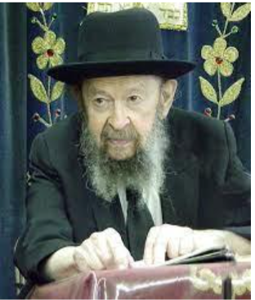

QUESTION: I just wanted to know, if all the goyim hate us then why do we see sometimes in history the goyim save Jews?
ANSWER: Let me tell you. אין למדין מן הכללות אפילו במקום שנאמר בו חוץ. (We cannot assume there are no exceptions to a rule, even when it already specifies the exception – Eruvin 27a). Sometimes there are exceptions. Sometimes there are exceptions, yes. When we say ‘all’ it doesn’t mean every single one. There are exceptions.
I want to make an announcement right here. I think that the people who founded this country, Benjamin Franklin, George Washington, James Madison and Thomas Jefferson were not Jew haters. They didn’t love Jews, no. They didn’t love Jews. No. But they were not Jew haters. They had a principle — Hakadosh Baruch Hu put a ruach in them, a spirit to found a nation with equal rights for everybody.
It wasn’t their own idea. Hakadosh Baruch Hu is in charge. פלגי מים לב מלך ביד ה׳ – Even kings’ minds are influenced by Hashem. I have a feeling that the founders of this country were influenced by Hakadosh Baruch Hu to be equal and fair and that’s why I don’t think they had prejudices especially against the Jews. Never does it mention anything from them that was against the Jews. Only the people in general — the Christians in general — can’t help themselves because their religion is full of hatred against the Jews. Everywhere you look in the New Testament they speak against the Jews.

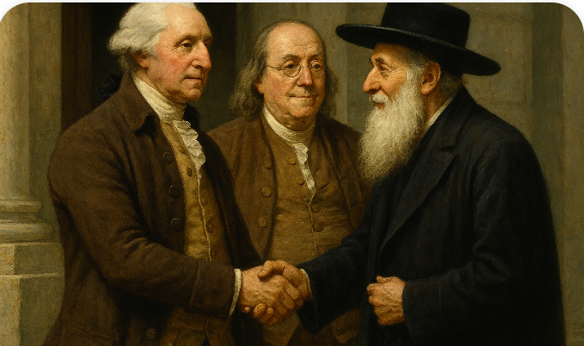

And therefore, I have a certain respect for the founders of the Constitution. Maybe I’m wrong but I have a feeling that they didn’t have any kind of animosity against the Jewish people. They wouldn’t go all out and embrace the Jew and kiss him and so on, and say achinu atah, but still they gave a Jew a full chance, a fair chance. That’s what I think.
And it wasn’t only due to them. Hakadosh Baruch Hu was in charge of that. He was the One who made America. Why did He make America? So we should be here today, to have a place of refuge.
You know, when Spain expelled the Jews, Galus Spania, at the same time, Columbus discovered America. The same time. It was the yad Hashem. The same king and queen that made the gezeirah to expel the Jews from Spain, they’re the ones who furnished the expedition of Columbus to discover America. You see the connection? America was discovered as a haven for the Am Yisroel. Hakadosh Baruch Hu is in charge.

Reprinted from the archives of Toras Avigdor. Transcribed from a classic Thursday night lecture delivered on March 16, 2000..

Thoughts that Count
For Our Parsha

Moses gathered together all the Congregation of the Children of Israel and said to them: "These are the things which G-d has commanded that you should do" (Ex. 35:1)
Every Jew approaches a mitzva (commandment) with his own thoughts and intentions, according to his intellect and understanding. Yet the physical performance of the mitzva is carried out in the same manner by all. Moses was able to assemble all the Jews in true unity because the performance of mitzvot is common to all Jews, irrespective of other differences. (Rebbe of Tshortkov)

All the wise-hearted among you shall come, and make all that G-d has commanded. (35:10)
It is preferable for a person to do a mitzva immediately, as the opportunity presents itself, and not procrastinate. Doing a mitzva with alacrity prevents all kinds of obstacles from arising to prevent its performance at a later time. That is why the verse says, "All the wise-hearted among you shall come" - one who is truly wise - "shall come" - without delay. (HaDrash Vehaiyun)
4
Earring, nose ring, finger ring and bracelet (35:22)
These items were donated for the Sanctuary to teach us an important lesson in raising our children: Earring - We must listen carefully to the Torah's dictates on child rearing, and must always hear what our children are saying to make sure they are receiving a good education; Nose ring - We must "smell out" our children's friends, to make sure that they are positive and not negative influences; Finger ring - We must point, so to speak, with our finger, the right path to follow, and explain the dangers of straying from that path; Bracelet - We must use our arms, that is, all of our strengths and resources, to ensure that every Jewish child receives a strong Jewish education. (The Lubavitcher Rebbe)

And he put in his heart that he may teach (Exodus 35:34)
This expression appears only once more in Torah, in the verse, "That you be able to teach the Children of Israel all the statutes which the L-rd has spoken through Moses," to teach us that whoever is blessed with wisdom and understanding of Torah is obligated to share it with others. (Parperaot LaTorah)

Reprinted from the Parashat of Vayakhel 5763/2003 edition of L’Chaim
Rabbi Shimshon of Sens
(Rash Mishantz), the
Great Redactor of Tosafot
By Yossi Ives

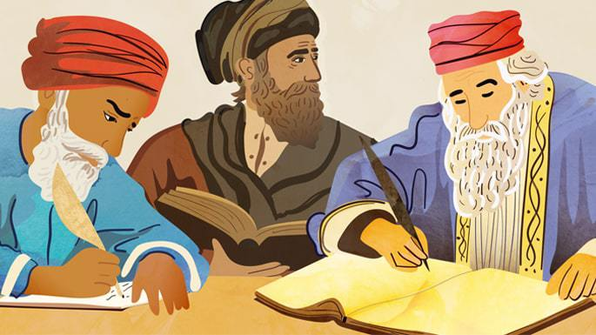
Art by Sefira Lightstone

One of the greatest and most important 12th-century Ashkenaz rabbis is also relatively unknown: Rabbi Shimshon ben Avraham of Sens, France, known in Judaic scholarship as “Rash Mishantz,” since Rash (ר”ש) is an acronym for Rabbi Shimson and Shantz (שאנץ) is the Jewish version of Sens. An immense scholar whose leadership bridged the 12th and 13th centuries, he was venerated and influential in his day, and his impact remains equally significant now.
Twelfth-century France saw the rise of the Tosafists, successive generations of scholars who pioneered a novel approach to interpreting the Talmud. The movement’s key founder and figurehead was Rabbeinu Yaakov Tam. Although he developed the approach, he left little in writing. He was, however, blessed with outstanding students – talented scholars in their own right – including his recognized successor, Rabbeinu Yitzchak the Elder (known as Ri). Ri systematized and recorded his teacher’s approach and disseminated it widely.
Ri similarly produced a large number of impressive students. Foremost among them, and the one who would be recognized as the leader of the third generation of Tosafists, was Rabbi Shimshon of Sens (Shantz), named for the location of the yeshivah he maintained after studying for decades under his mentor, Ri.
Rabbi Shimshon was born around 1150 in the city of Falaise, in the Normandy region of France.¹ We know of two sons, both of whom were rabbis. The younger one, Shlomo, also established himself as a great scholar. Rabbi Shimshon passed away in 1230 in the city of Acre (Akko) in the Land of Israel, and lies buried at the foot of Mount Carmel, together with other outstanding greats, such as Ramban (Nachmanides), and his own two sons.
In addition to being known as Rash Mishantz, he is occasionally referred to by the acronym Rashba, as well as the moniker Hasar Mishantz, meaning “the Count of Sens.” How did he get the name (since he definitely wasn’t a count!)? The illustrious Chida (Rabbi Chaim Yosef David Azulai) found an ancient manuscript explaining that since Rash (the acronym for Rabbi Shimon) also means ‘poor’ in Hebrew, which is unflattering, they reversed his acronym, which then read as sar, meaning “count.”²
Rash’s opinions carried enormous weight. Rabbi Yitzchak of Vienna, one of the great halachic authorities in the succeeding generation, described Rash as “unique in his generation for his scholarship and wisdom.” ³ Several generations later, Rabbeinu Asher, one of the greatest halachic authorities of his time, wrote, “Rabbeinu Tam, Ri, and Rabbeinu Shimshon, upon whose scholarship most of our scholarship is based.”⁴
As we shall see, he used his influence wisely and to good effect.

Tosafot Commentary
Since 1484, the Talmud has (almost always) been printed with a Tosafot commentary on the outer margin of the page, complementing Rashi’s commentary on the center margin. This has produced the iconic design of the Talmud. A great deal of the Tosafot commentaries to the 37 tractates of the Babylonian Talmud are derived from the version of Tosafot composed by Rash. Undoubtedly, the work of Rash in arranging the Tosafot into a well-organized commentary is what made the distribution of the Tosafot across Europe and beyond so successful.
The text that appears in today’s printed Talmud is typically an edited-down version of Rash’s own commentary, which once covered the entire Talmud. This was done in the generation following Rash for brevity, resulting in a sometimes cryptic text that is difficult to decipher. While most of the original writings from which our current Tosafot commentaries were drawn have been lost, we do still have the original commentary of several tractates, published under the name Tosafot HaRash Mishantz.⁵
Given the dense and complex nature of the Tosafot, thousands of explanatory commentaries arose. By contrast, Rash’s own version is fuller and clearer, resolving many of the knotty problems that generations of scholars worked to address.
In addition, Rash’s version is richer, revealing fascinating details about how the discussions unfolded in Ri’s academy. What may sometimes be limited to a punchline in the printed Tosafot is presented as a blow-by-blow account in Rash’s version. Rash’s commentary also incorporates broader implications of the discussion, even when not strictly relevant to the immediate topic at hand. For example, in a discussion about whether beer is chametz (and thus forbidden for consumption on Passover), Rash discusses the appropriate blessing to be said when drinking beer.⁶
Rash was not the originator of Tosafot, nor the systemizer, but he was the ultimate compiler, popularizer, and disseminator. As a gifted teacher and communicator, he turned the Tosafot approach of his predecessors into a reliable commentary on every page of the Talmud.

Great Maimonides Dispute
While Rash was the leading Ashkenazic scholar in France, Maimonides was the leading Sephardic scholar in Egypt. As Maimonides’ major works became known, they aroused controversy. Leading rabbis took sides, either supporting or opposing Maimonides’ positions.
The leader of the critics was Rabbi Meir ben Todros Abulafia from Toledo, Spain. In particular, he objected to what he perceived as Maimonides’ questionable views about the Judaic belief in the eventual revival of the dead (techiyat hameitim). He also sternly objected to some of Maimonides’ more philosophical views, deeming them antithetical to traditional Torah teachings. Rabbi Meir Abulafia strove diligently to rally leading rabbis of France to support his position, with limited success.
Rabbi Meir attempted to convince Rash to come out openly against Maimonides, but Rash steadfastly refused to participate in the dispute. He insisted that while he agreed with the criticism, his great respect for Maimonides precluded him from speaking negatively. Eventually, Maimonides published a clarification about the most contentious of his views, and part of the dispute subsided.⁷
In this way, Rash helped to lower the flames of discord that threatened to inflame the entire Jewish community.
Notwithstanding his utmost respect for Maimonides, Rash was strongly critical of the way he omitted any sources in his vast halachic code, the Mishneh Torah. In his view, in the absence of sources, it was impossible to independently assess the validity of Maimonide’s rulings. He also considered this a sharp deviation from traditional norms.
Nevertheless, Rash maintained the utmost civility and respect while holding true to his views—a hallmark of his scholarship and leadership.

Love for the Land of Israel
Rash maintained a powerful interest in the Land of Israel. More than others before him, he heavily incorporated ideas from the Jerusalem Talmud into his writings. At that time, the Babylonian Talmud predominated, and the Jerusalem Talmud, representing the learning of the Land of Israel, was relatively unknown. Rabbi Shlomo Luria (Maharshal), the great sixteenth-century halachic authority, noted that Rash was proficient in the Jerusalem Talmud “more than anyone else we have heard of.”⁸
Rash wrote a pioneering commentary on the Mishnah, focusing on tractates with no Talmudic commentary. Those sections were also the ones most focused on the laws pertaining to the Land of Israel. To this day, Rash’s Mishnah commentary serves as a foundational text.
In 1211, Rash fulfilled his dream and traveled to the Land of Israel together with around 300 Tosafists and other Jewish notables from France and England. Part of his drive to leave France was due to anti-Jewish persecution instigated by Pope Ignatius the Third. Rabbi Moshe Isserles recalled, “When the persecution of the Jews of France intensified, he went up to Israel.”⁹ His choice of destination, however, was motivated by his longstanding interest in and passion for everything related to the Holy Land. No doubt, Saladin’s 1187 conquest of the land from the Crusaders meant the area was far safer for Jews, enabling him to settle there.
At first, he resided in Jerusalem, which earned him the moniker, “the Jerusalemite.”¹⁰ In 1229, Rash and his colleagues were forced to flee Jerusalem when it once again fell into the hands of the Crusaders. Rash moved to the Northwestern city of Acre (Akko), where he lived for 19 years. His descendants continued to reside in Acre for several generations. Eventually, the area was conquered by the Mamluk Muslims from Egypt, and Rash’s grandson is listed among those murdered.
Eight hundred years after Rash illuminated the world with his exceptional scholarship, we remain indebted to him. He not only made an outstanding contribution to Judaism in his day, but his legacy continues to live on in every Talmud student who benefits from his devotion and skill, faith and leadership. If you find yourself near Acre, make a point of paying your respects at his graveside on behalf of dozens of generations whose studies he immeasurably enriched.

Footnotes
1. Baalei Hatosafot by Efraim E. Urbach.
2. Shem Hagedolim, Erech Rashi (Maarechet Gedolim Ot Shin, p. 178). The manuscript also explains how Rashi came to be called by his name, as his acronym would also have spelled Rash, poor.
3. Ohr Zarua, Bava Kama 436.
4. Teshuvot HaRosh 84.
5. The first volume was published in 1956 on Tractate Pesachim.
6. Tosafot Rash Mishantz, Pesachim 2a.
7. Rambam’s Iggeret Techiyat Ha-Meitim (Treatise on Resurrection).
8. Yam Shel Shlomo, Introduction, Bava Kama.
9. Teshuvot HaRema 31.
10. Sefer Mitzvat Gadol, Asin 45.

Parnassah in the
Merit of Shabbos

A Polish Jew once came to the Yismach Yisroel of Alexander zy”a and related that although he owned a store, he had very few customers and he was unable to make a sufficient livelihood. From the course of the conversation, the Rebbe was able to discern that the man’s store was open on Shabbos.
The Yismach Moshe told him, “I can guarantee you success in your business on one condition. You must take me as a 15% partner without me having to invest one dollar into the business. If you accept these terms, I promise you success.”
Of course, the man agreed to the deal, and a contract was written up.
The Yismach Moshe then told him, “Since I now own one-seventh of your store and I am entitled to one-seventh of the profits, I choose to take Shabbos as my day. All the profits you earn on Shabbos will be mine, while the profits from the other six days will be yours Therefore, I ask you to close the store on Shabbos.”
The man understood what the Rebbe was saying. From then on, he closed his store on Shabbos and he saw much financial success.

Reprinted from the Parshas Vayakhel-Pekudei 5786 email of The Way of Emunah: Collected Thoughts on the Weekly Parshah from Rabbi Meir Isamar Rosenbaum.

